Visual proof

Headphones before fine-tuning | 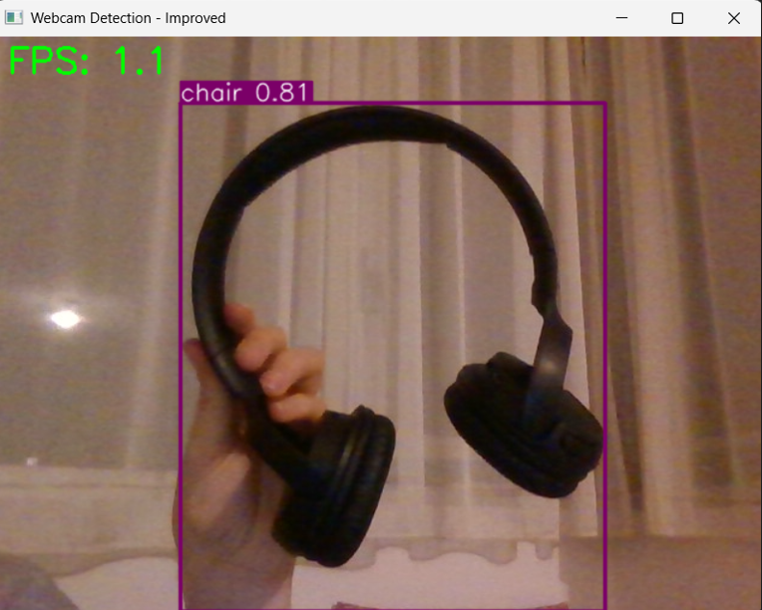
Headphones after fine-tuning | 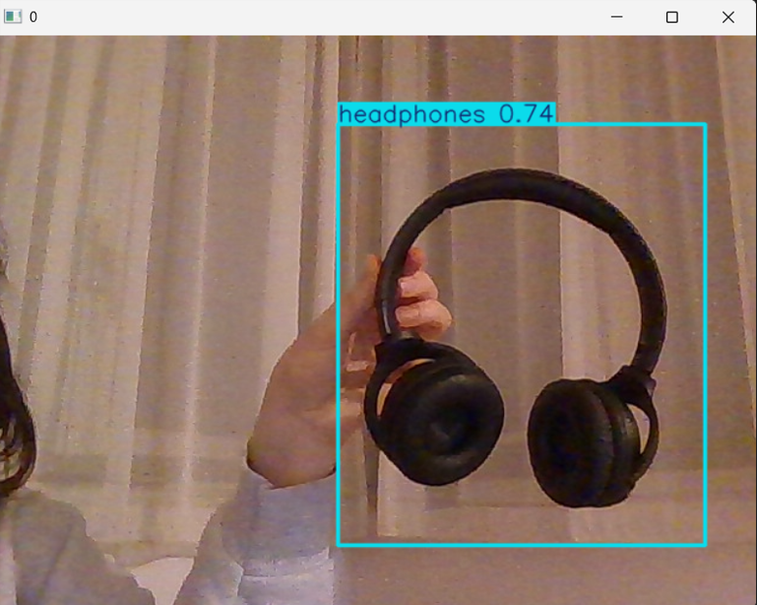
Pencil case before fine-tuning | 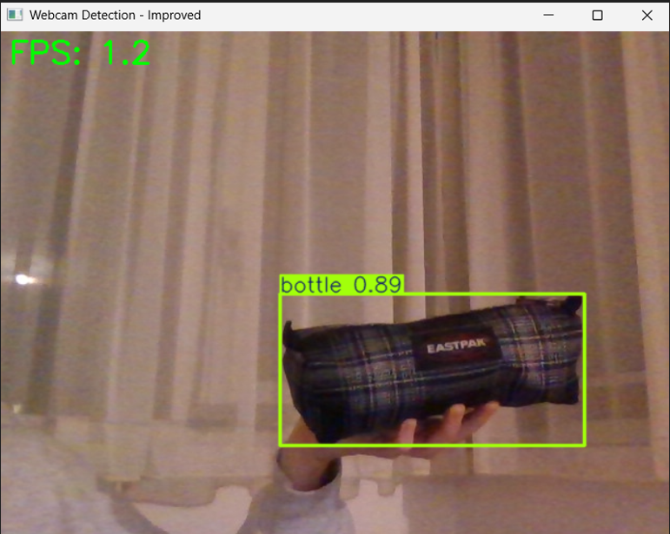
Pencil case after fine-tuning (with the timer feature included) | 